HPE Container Platform – Kubernetes Application Image Development

Lab Solution Worksheet

Deploy “Hello World” Kubernetes Application via Web Terminal 2

Deploy Application in HPE Container Platform 2

Accessing Application 6

Deleting Application 7

# Deploy “Hello World” Kubernetes Application via Web Terminal

This lab is to deploy a sample Hello World application.

## Deploy Application in HPE Container Platform

1. Login to HPE Container Web UI

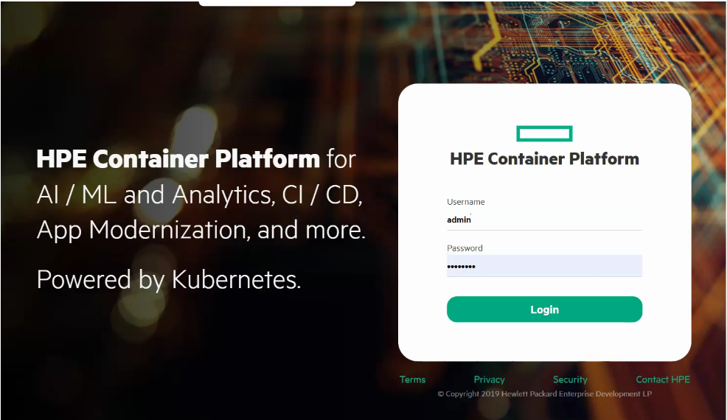

1. From left-hand menu, click on **KUBERNETES** drop-down menu
2. Click on **Tenants** and enter any tenant

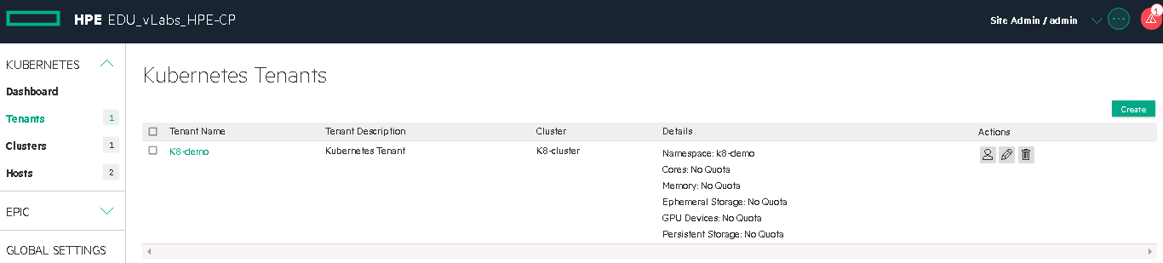

1. Click on **Applications**

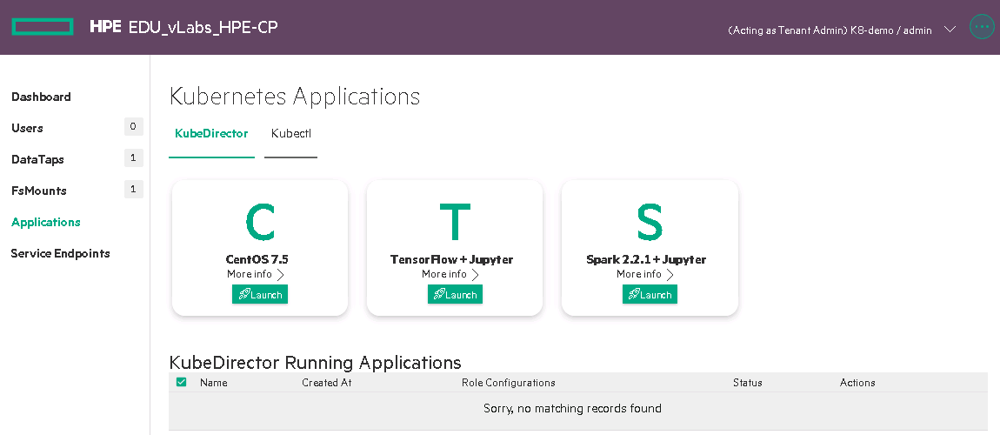

1. Open Web terminal form below

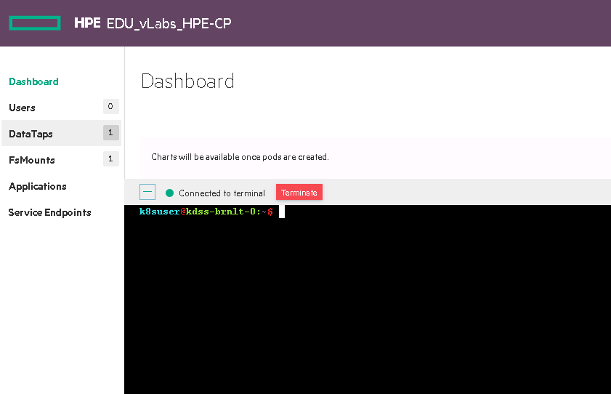

1. Create a directory for the application & navigate to it

k8suser@kdss-brnlt-0:~$ **mkdir helloworld**

k8suser@kdss-brnlt-0:~$ **cd helloworld/**

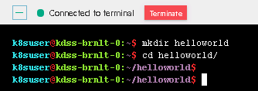

1. Create a YAML file

k8suser@kdss-brnlt-0:~$ **vi app.yml**

1. Copy the content from **C:\bluedata_share\HPECP-AppImage-K8s\HelloWorld\app.yaml** file and paste it in **app.yaml** file in web terminal
2. Save and exit the file
3. View the content of **app.yaml** file

k8suser@kdss-brnlt-0:~$ **cat app.yaml**

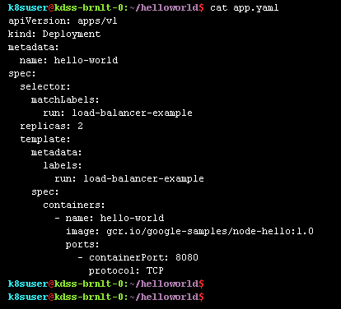

1. Execute the YAML file using kubectl command

k8suser@kdss-5b2kp-0:~/helloworld:~$ **kubectl create –f app.yaml**



1. Create a web service YAML file to expose the application

k8suser@kdss-brnlt-0:~$ **vi app-svc.yaml**



1. Copy the content from **C:\bluedata_share\HPECP-AppImage-K8s\HelloWorld\app-svc.yaml** file and paste it in **app-svc.yaml** file in web terminal
2. Save and exit the file
3. View the content of **app-svc.yaml** file

k8suser@kdss-brnlt-0:~$ **cat app-svc.yaml**

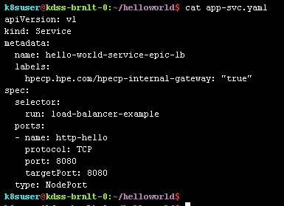

1. Execute the YAML file using kubectl command

k8suser@kdss-5b2kp-0:~/helloworld:~$ **kubectl create –f app-svc.yaml**



1. Verify

k8suser@kdss-5b2kp-0:~/helloworld:~$ **kubectl get pods**

k8suser@kdss-5b2kp-0:~/helloworld:~$ **kubectl get deployment**

k8suser@kdss-5b2kp-0:~/helloworld:~$ **kubectl get service**

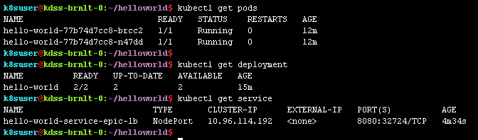

1. This procedure launches a browser-accessible web service application. You can find the external link details by executing the following Kubectl command

k8suser@kdss-brnlt-0:~$ **kubectl describe service hello-world-service-epic-lb**

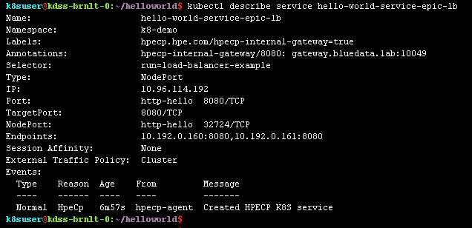

## Accessing Application

1. Use the hostname and port to access the Hello World application



OR

1. Click on **Service Endpoints**

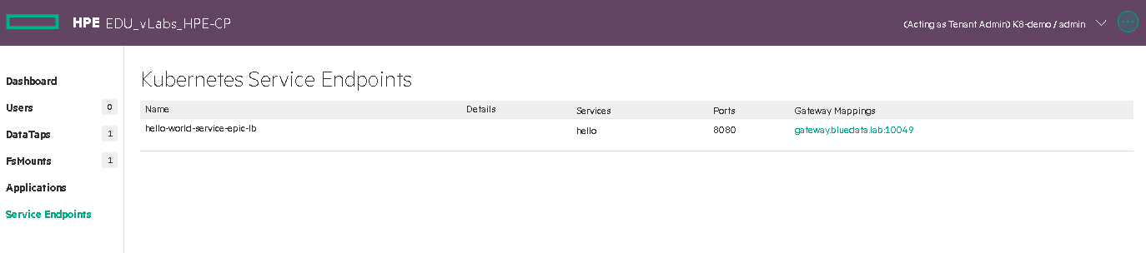

1. Click on Gateway Mappings entry, it will open-up a new tab of the Hello World application

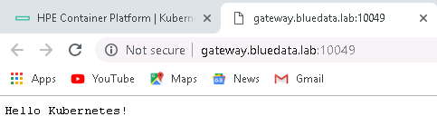

## Deleting Application

1. To delete application, execute

k8suser@kdss-brnlt-0:~$ **kubectl delete deployment hello-world**

k8suser@kdss-brnlt-0:~$ **kubectl delete service hello-world-service-epic-lb**

